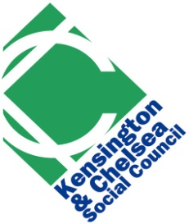 | Health & Wellbeing Forum  18 October 2022, 10.00am – 11:30am  Via Zoom

AGENDA

10:00 - Welcome and Introduction – Angela Spence, CEO, KCSC

10:10 - Networking Opportunity

10:20 - Presentation and discussion on developing a voluntary and community sector health and wellbeing strategy - Lev Pedro & Aimie Cole

11:15 - Sharing updates

11:25 - Feedback and AOB

11.30 Close of meeting

